Responsiveness Evidence
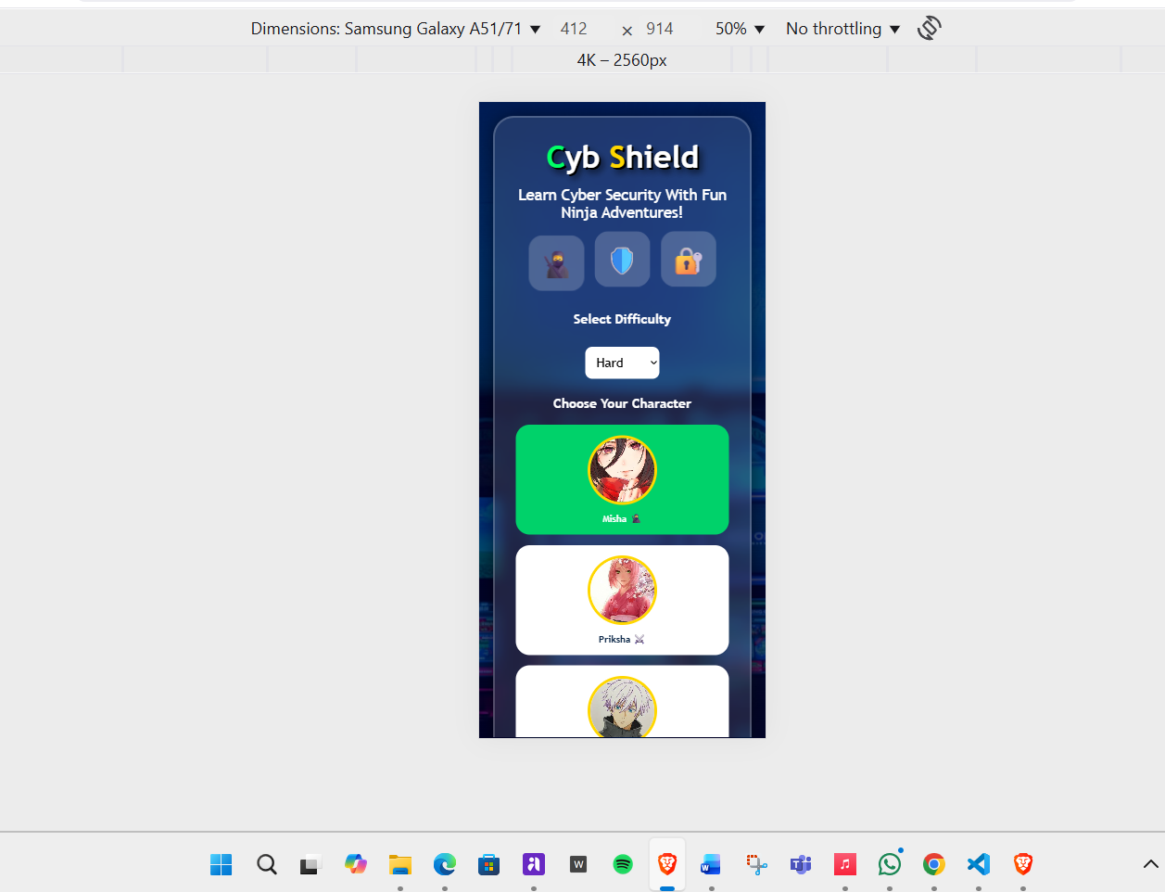
Figure 1 CybShield in mobile phone
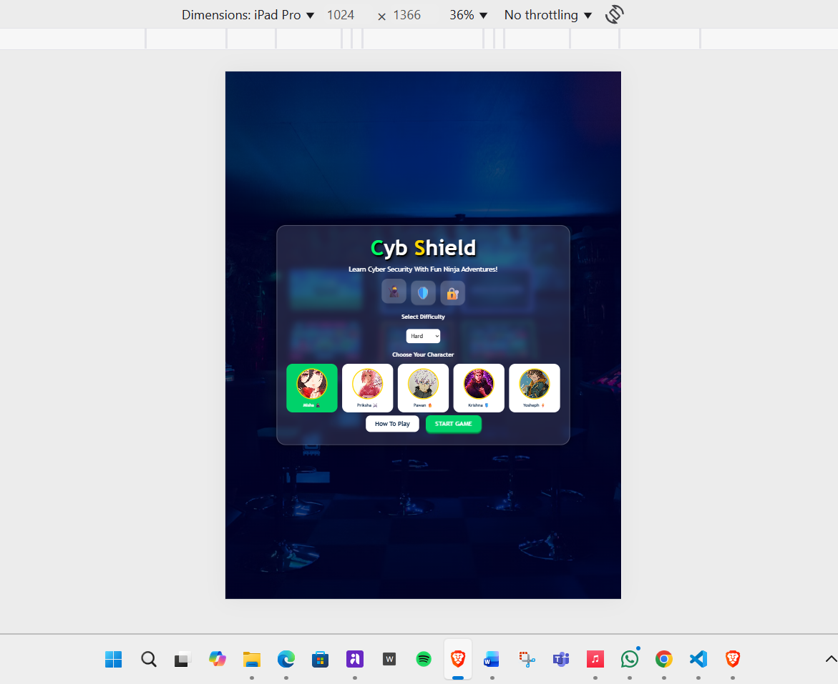
Figure 2 CybShield in Tablets


Figure 3 CybShield in PCs

In conclusion CybShield is responsive to all three device types i.e. mobile phone, tablets and PC

